ACTIVITY 5.1 Post-war migration
policies in Australia
At the end of World War II, a new immigration policy was established in Australia. The goal was to foster economic growth and to increase Australia’s population substantially. Arthur Calwell, the Minister for Immigration, said that we needed to ‘populate or perish’, and developed a number of policies to increase the number of migrants from Britain and war-torn Europe.
› Identify and analyse the perspectives of people from the past
› Develop historical texts, particularly explanations and historical arguments, that use evidence from a range of sources that are referenced
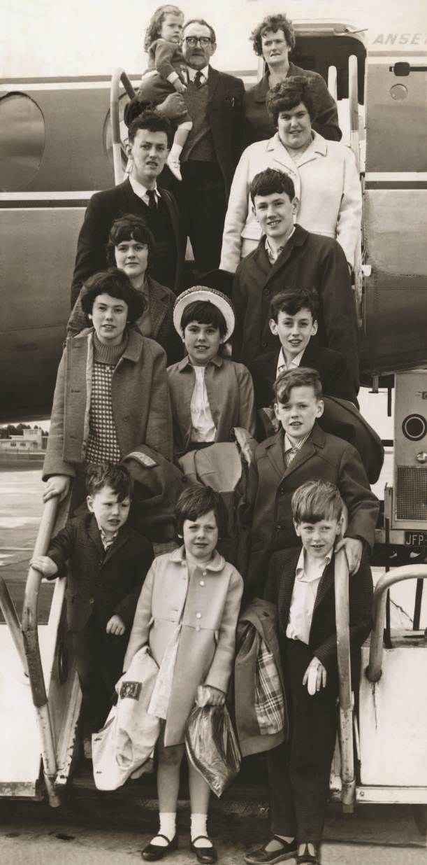
Between 1945 and 1965, more than two million migrants came to Australia. Many of these were ‘assisted’, which meant that the government paid most of their fare to get here. The assisted passage scheme initially targeted British people. However, as European economic conditions improved and interest in migration from Western Europe lessened, migration from Southern and Eastern Europe became necessary if Australia was to continue to reach target figures.
AUSTRALIAN CURRICULUM
HISTORICAL SKILLS
In 1947, the Australian Government reached agreement with the International Refugee Organisation to take in some of the many people who had been displaced by the war and were being accommodated in refugee camps. The first group of 839 young men and women from Estonia, Latvia and Lithuania arrived at the newly opened Bonegilla Reception and Training Centre in Victoria in December 1947. Their arrival was carefully publicised by the government to persuade and reassure the Australian public that the immigration program was a positive thing for the future of Australia. They were described in the media as the ‘Beautiful Balts’.
By 1951, Australia had taken in more than 170 000 of Europe’s displaced persons, including people from Poland, Yugoslavia and the Baltic States. In return, these people had to agree to stay in Australia for at least two years and work in whatever jobs the government gave them.
As this source of immigrants began drying up, the Federal Government negotiated a series of migration agreements with other countries, including the Netherlands and Italy (1951), Austria, Belgium, West Germany, Greece and Spain (1952), and the United States, Switzerland, Denmark, Norway, Sweden and Finland (1954). As a result, Australian society became significantly less British and Irish in character. This was a concern to those who preferred British immigrants.
In 1956, the government started the ‘Bring Out A Briton’ campaign, which was primarily aimed at Australian communities and involved the sponsoring of British migrants to come to Australia and bolster the Australian British population. Local communities or businesses were encouraged to assist a British family and help them settle in Australia to boost labour-force skills, help populate the country and maintain a strong British presence across the nation. Despite this, by 1961, eight per cent of the population was non-British in origin, with the largest group being Italians, followed by Germans, Greeks and Poles.
Source 1 Northern Irish migrant family
arriving in Melbourne in 1966. They were
the largest family to be brought out under
the ‘Bring Out A Briton’ scheme.

It was not until the election of Gough Whitlam as the Prime Minister of Australia in 1972 that the ‘White Australia Policy’ was finally abandoned. Migrants were to be chosen according to personal and social attributes and occupational group rather than country of origin. The new Minister for Immigration, Al Grassby, declared Australia a ‘multicultural society’ and announced that ‘every relic of past ethnic or racial discrimination’ was to be abandoned and migrants welcomed from all countries.
I would like to emphasise that the Government’s immigration policy is based on the principle that migrants from the United Kingdom shall be given every encouragement and assistance. It is my hope that for every foreign migrant there will be ten people from the United Kingdom. Only time will tell how far this hope can be realised. We have already given indubitable evidence of our preference for the United Kingdom migrant by entering into agreements with the United Kingdom government for the granting of free and assisted passages to suitable people from the United Kingdom. Aliens are and will continue to be admitted only in such numbers and of such classes that they can be readily assimilated … The call to all Australians is to realise that without adequate numbers this wide brown land may not be held in another clash of arms, and to give their maximum assistance to every effort to expand its economy and assimilate more and more people who will come from overseas to link their fate with our destiny.

Source 2 Excerpt from a speech given by Arthur Calwell, Minister for Immigration, during the Commonwealth
Parliamentary Debates, House of Representatives, 22 November 1946

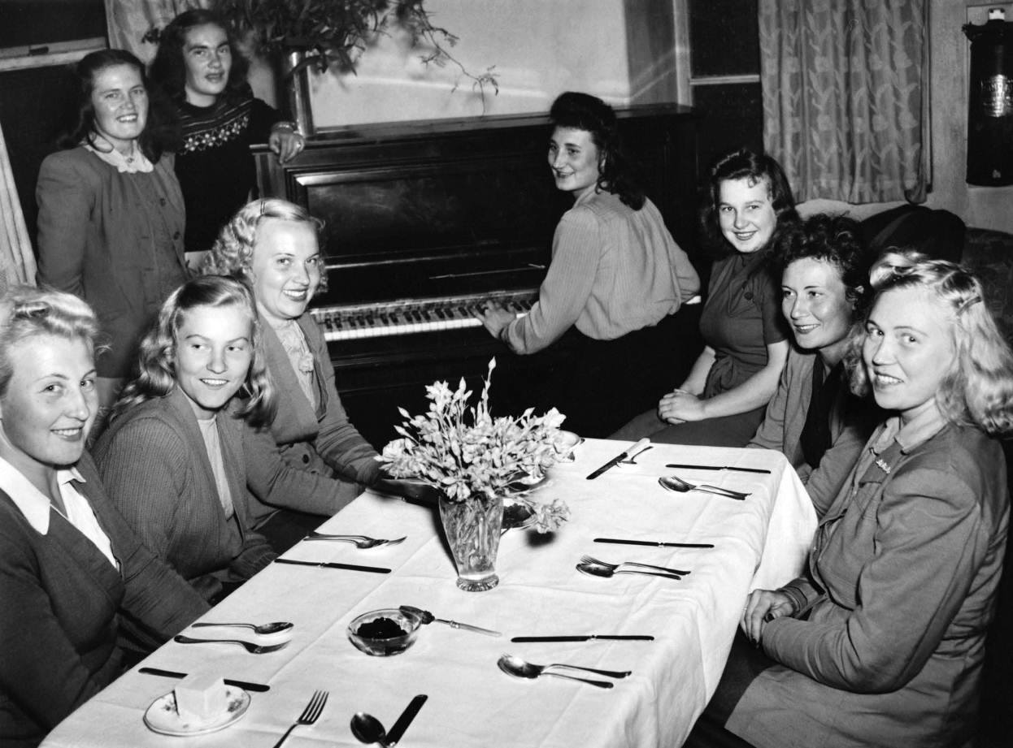
Source 3 The ‘Beautiful Balts’: photograph of some of the first group of displaced persons from Europe in 1948.
Albury’s Border Morning Mail described the new arrivals as ‘attractive, cheery, eager to work and neatly clad’;
the women had ‘surprisingly good complexions and figures’ with ‘splendidly formed white teeth’.

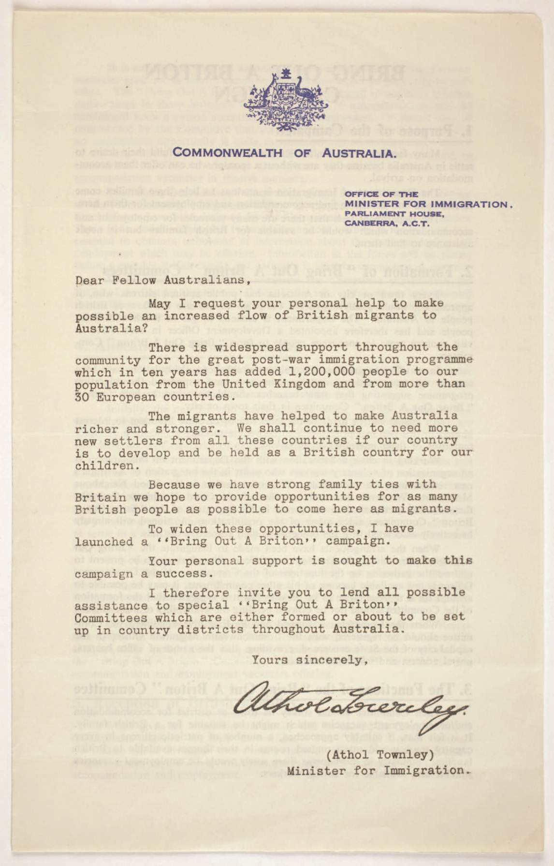
Source 4 ‘Bring Out A Briton’ campaign leaflet, Commonwealth of Australia, c. 1957

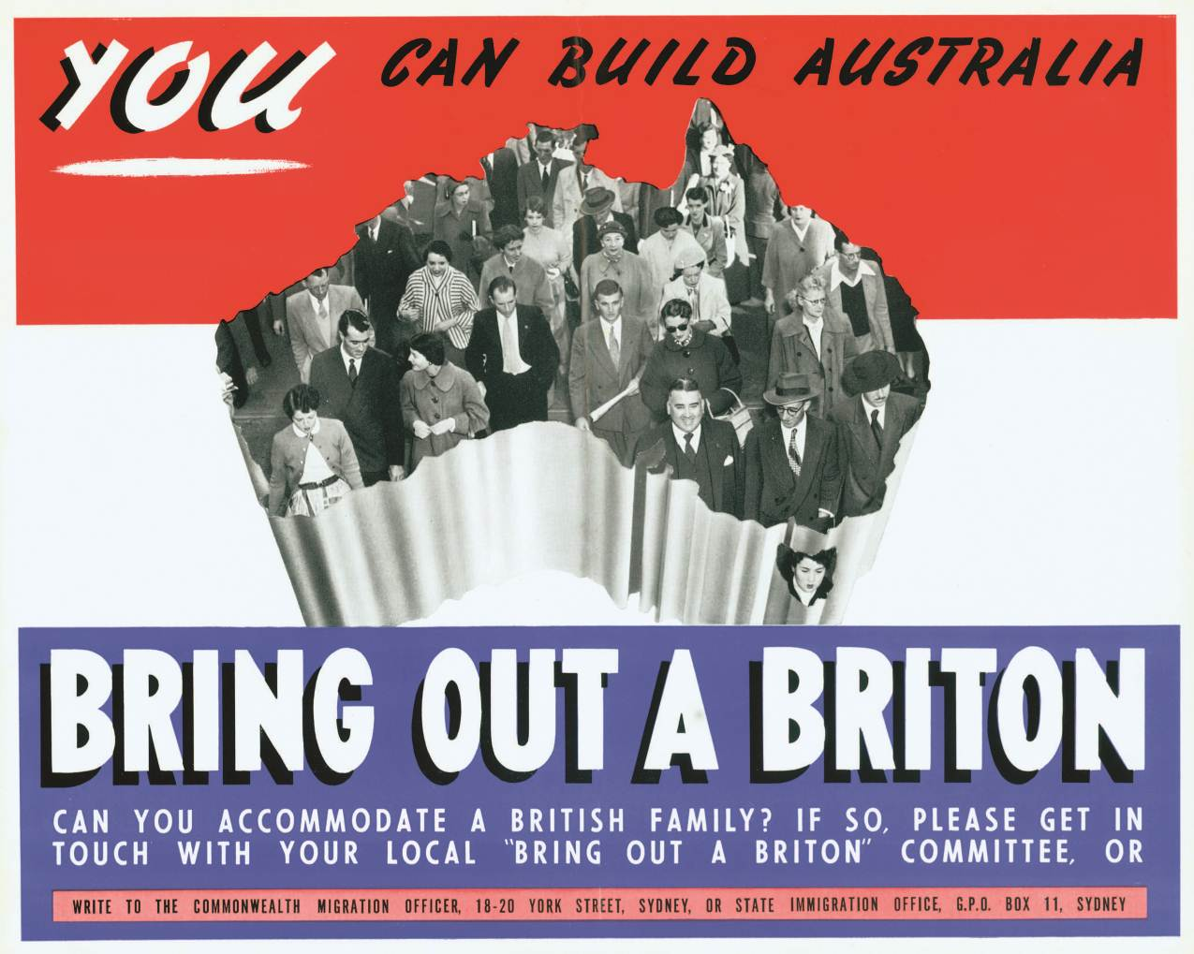
Source 5 ‘Bring Out A Briton’ poster, 1961

We removed the assertion that a primary national objective must be to increase population. We removed the commitment to expand the immigration program. We related our immigration needs simply to the capacity of Australia to provide ‘employment, housing, education and social services’—in other words a very specific instruction to the incoming Labor Government that people, the welfare of people, the people already here and the people who may come, must be the prime consideration, not mere numbers. And thirdly we said unequivocally that there must be no discrimination on grounds of race or colour or nationality.

Source 6 Extract from Gough Whitlam’s autobiography where he discusses the changes
he proposed to the immigration policy during his 1971 campaign
Questions (answer in this document):

- Using the information provided (as well as your own knowledge), explain why Arthur Calwell and the Australian Government was so keen to increase Australia’s population after World War II.

- Who were the ‘displaced persons’ and why were they so important to the migration program? How and why did the Australian Government attempt to position the Australian people to view these displaced persons in a particular way?

- What was the ‘Bring Out A Briton’ campaign and why was it established?

- In what ways did the Whitlam government change Australian immigration policy?

- In two – three sentences, describe the shifts in Australian attitudes towards immigration in the post–World War II years. Use evidence from Sources 2 – 6 to support your response.

